MACM 316 Computing Assignment #1

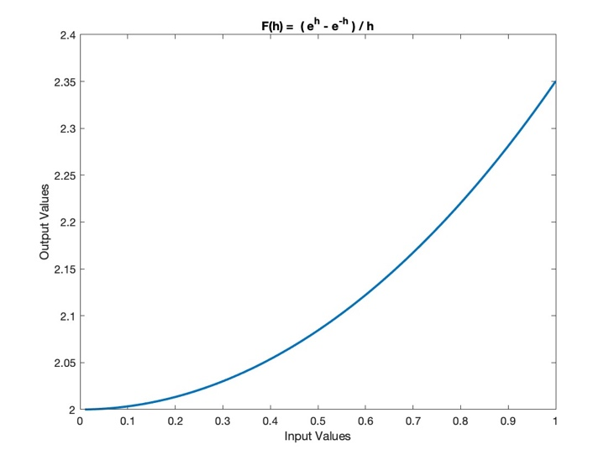

1. By using different values of *h* we can see that as *h* goes to 0, *F(h)* approaches 2. If *h* is chosen too small, however, the numerator runs the risk of a cancellation error due to bit-limiting factors in the mantissa. Since will evaluate arbitrarily close to as *h* 🡪 0, cancellation errors caused by rounding in both and will lead to incorrect results in the computation. The errors in these terms may also oscillate in severity, causing further unpredictability.

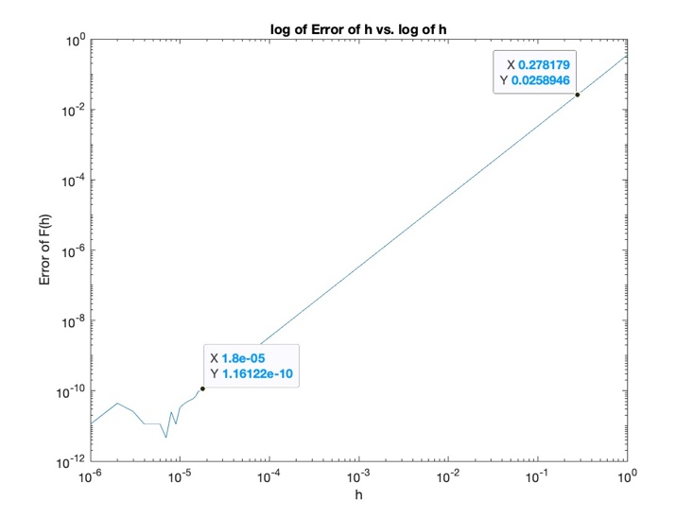

1. It can be shown using Taylor Series for that .

Since *F(h)* evaluates to 0/0, to find the limit of *F(h)* we can also use L'Hôpital's rule in the third equality of the following:

A third approach is given by plotting the error of F(h) against h. Since the relationship is exponential, we linearize using logarithms (thank you to Garrett during office hours for the suggestion and assistance). Since the relationship is now linear, we note the following about the line:

Since is constant we may ignore it for our purposes. Solving for the slope, *m,* on the other hand, will bound the rate of convergence of the error. Choosing points on the plot we have

Where